Cable ties/wraps

How tight should a cable tie be? Finger tight.
A bad example, notice the cables being deformed. Most consultants will refuse to sign off on a cable system if they see this, even if the test results show a pass.
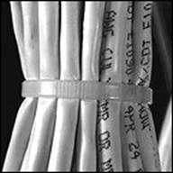
You do not need to pull hard on the cable tie to secure the cable. Here is a good example where the cables are not deformed:
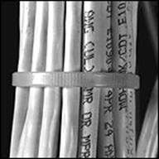
There is a move in the industry to use Velcro wraps. They do not apply as much pressure to the cable sheath. An interesting alternative is the Mille-Tie, shown below:
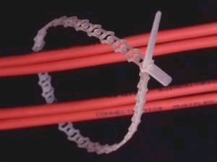
The plastic has a certain amount of elasticity. The cool thing* is that you pull the Mille-Tie tight, cut off the excess and use the excess to tie the next bundle reducing wastage. It also avoids the need to clear cut offs from the floor.
*This is not an endorsement for the Mille-Tie

